The G3PLX Mk2 rtty

video display unit
by J. P. MARTINEZ, G3PLX
AMATEUR radioteleprinter activity has until now relied on the use of second-hand teleprinters for transmission and reception, but recent advances in mos ic technology háve made a solid-state rtty terminál not only a possibility but an attractive proposition for amateur rtty. This article, describing the iogic design of such a unit, should be of interest both to amateurs already familiar with teleprinter operation, and to those who háve hitherto been dissuaded from trying rtty because of the noisy, mechanical nátuře of the equipment ušed. In describing this video display unit, the author assumes that the reader has some basic knowledge of rtty and Iogic circuits. However, all the background information on rtty is given in the Rádio Communication Handbook, and the senes of articles “Learning about Iogic” by G3FRJB, in Rádio Communication from June 1976 onwards, contains all the background information about Iogic circuits. The Mkl vdu, on which this unit was based, was demonstrated at the British Amateur Rádio Teleprinter Group convention in May 1976. The Mk2, developed later, was designed for simplicity and low cost. The ics ušed in this design cost about £50 in December 1976.
Fig 1 shows the block diagram of a typical amateur station using a vdu systém for rtty. The audio output of the receiver is demodulated by the frequency-shift converter to give a logic-level output which is taken to the vdu Iogic unit. The output of the Iogic is a video signál and synchronization signals, which can be combined and modulated on to a carricr in the uhf tv band and fed to the antenna Socket of a domestic 625-line tv receiver. Altematively the video and syne signals can be fed direct to purpose-built timebase and crt drive circuitry, perhaps using parts from an old tv set. Although this second approach gives a better quality display and can result in a complete self-contained unit, it rcquires some knowledge of tv circuitry, which is beyond the scope of this article. The latter schcme was the one ušed by the author, who ušed parts from a 12in portable tv receiver, thus over- coming the problems associated with the live-chassis construction of larger rcceivers.
Transmission of rtty signals is also carried out by the vdu, theinput being from a 31-switchkeyboard which can beeither a commercially available unit or a home-made device. The rtty output from the unit is at Iogic levels and can be ušed to kcy the transmitter, and, of course, be fed back to the vdu input to monitor the outgoing message.

The capabilities of the vdu
The vdu can receive theoretically about 4,000 characters per second, the spced being determined by a simple RC time- constant network. The display takés the form of 24 lineš of 40 characters. This is a shorter line than the standard teleprinter, which has about 70 characters on a line. A vdu with a 70- character line would need a display with rather better deRnition than the average domestic tv set, and with the video at the 625-line standard it would need fast memories which at the present time are not cheaply available. So 40 characters per line is a compromisc, although it is becoming a standard for this sort of display. The BBC and IBA teletext systems use 24 lineš of 40 characters, and indecd it would not be difficult to add circuitry to this vdu to enable it to copy teletext.
In addition to responding to received carriage return and line feed codes by starting on a new line, if the received line is Ionger than 40 characters the vdu continues writing on the next line with no letters missing. When all 24 lineš are full, writing starts on the top line again, replacing old copy with new copy. The sereen can be cleared manually at any time, and there is also manual control of carriage return, line feed, “letters” and “figures” functions. A “page return” button is also fitted to reset the vdu to the top left corner of the sereen before receiving a message. The “bell” and “who are you?” characters are decoded in the vdu as they are received and operáte Iogic outputs that are available for uses external to the vdu.
Although the Iogic circuitry could all be built on pcbs, the author preferred to use commercially available dual-in-line layout cards with a standard printed track pattem, wiring the interconnections between dcviccs with self-fluxing polyure- thane-insulated wire. This method makes modifications and improvements to the unit very časy at a later dáte. The circuitry divides into three main areas—the input unit, the mentory and display and the timing circuits—and these can be built on three standard boards plugged into 43-way edge connectors. The power supply requirements are 5V at 0-9A, — 12V at 30mA, and +12V at a few milliamps for the uhf modulátor if this is ušed.

VDU Circuit deseription
The block diagram of the vdu is shown in Fig 2, the heart of which is the memory block. This can be thought of as 24 rows of 40 Iocations, each capable of storing a character code. Incoming rtty is converted from series to parallel form by the universa! asynchronous receiver/transmitter (uart) and stored in successive Iocations in the memory as it is received. The whole content of the memory is read out, character by character and row by row in syne with the tv line and frame scan, and each character code selects the shape of the corresponding letter from the 64 possible shapes stored in the character generátor memory. This is a read-only memory (rom) which Stores the letter-shapes as an array of black or white points in the form of a rectangle five units wide by seven units high. The video output waveform of the vdu is assembled from this information by a shift register driven by timing signals synchronous with the stream of character codes from the memory. The character generátor devices available, being primarily intended for Computer applica- tions, require inputs in ASCII code, and so the Murray-coded rtty input must be converted to this form. This is doně between the uart and the memory by a programmable read- only memory (prom), which is also programmed to decode the control characters in the incoming rtty.
Since it is not possible to write into one location at the same time as reading from another, the two operations are separated. The read/display operation takés plače during the

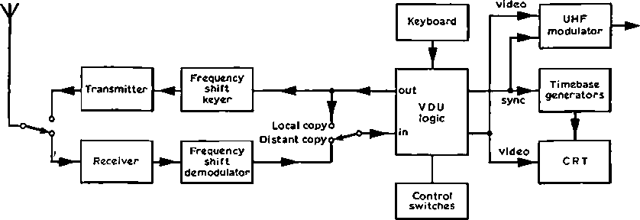
visible tv linescan, and any rtty character received during tbis time is held in the uart until the line flyback period, when control of the mentory is handed over to the input unit, and the waiting character is then writtcn into its correct location.
To
televislon
set
Fig 1. Block diagram of typical amateur rtty station using a vdu, showing the use of either a uhf modulátor with a domestic tv or a
purpose-bullt crt display
The timing chain starts with a 7,000kHz crystal oscillator using two gates IC30c and IC30d. The 7MHz square-wave is divided by seven in IC31, a divide-by-16 counter with feedback via gates IC37a and IC35d to shorten the count cycle. The resulting 1MHz pulse train is divided by 64 in IC32 and IC33. The six intermediate outputs of these counters are taken to the mentory column address lineš, so that during the hrst 40/xs of this count sequence the mentory will output one complete row of 40 character codes. Gate IC39b goes low between 48 and 52/xs and this is ušed to synchronize the line flyback at the end of a row. Flip-flop IC34a is set at 40/xs, and reset at 64/xs; this output is ušed to transfer control of the memory to the input board during the
line flyback interval. The line syne pulse front IC39b is further divided by 10 in IC36 and the outputs are gated by IC38b, c and d, so that the modified outputs count in the binary sequence 1 23456700 0. These outputs go to the row-select pins of the character generátor device IC17. When this row-select counter is at count 1, the five outputs of the character generátor will be at high oř low logic levels corresponding to the five black or white points on the top row of the five by seven rectangle. As the memory outputs change at lps intervals, so too will the character generátor outputs. These five signals are Ioaded in parallel into five of the stages of an eight-bit shift register IC16 and shifted out of the register in sequence by the 7MHz clock. The output of IC16 is the video output of the vdu, and so far bas traced out the tops of a row of characters. On the next tv line the row-select will be at count 2, and the character generátor outputs are programmed to give the second row of five points. After seven tv lineš the video output will have

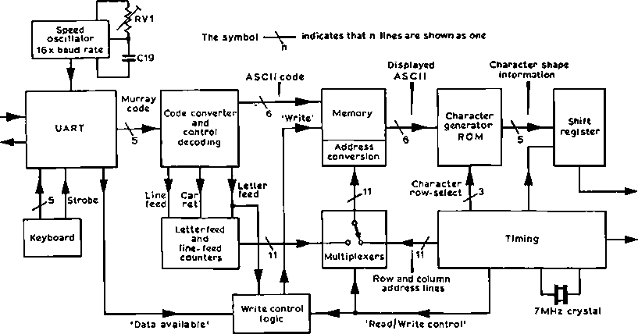
RTTY in RTTY out
Video
out
TV
syne
Fig 2. Block diagram of vdu logic

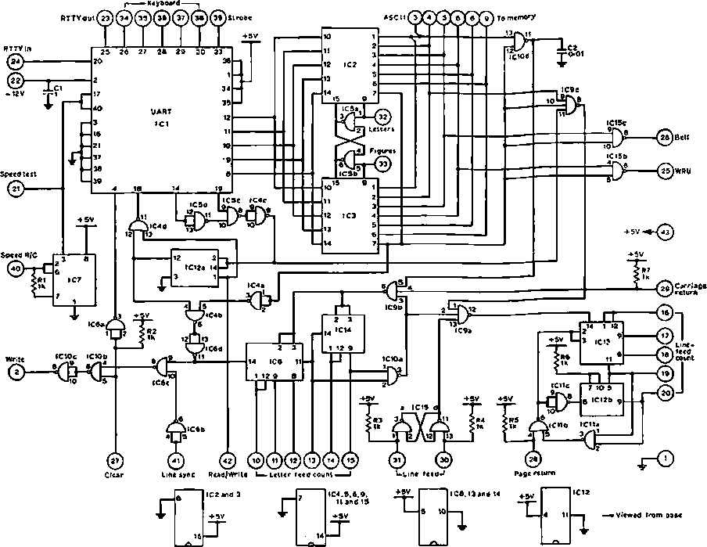
Fig 3. Input board. Figures in circles are edge connector pln numbers. C3, 4, 5 and 6 across t5V supply not shown

traced out the shapcs of the characters in one row of the memory. The character generátor is programmed so that row-select count 0 gives no output, and so the following three tv lineš will display blank, giving a margin separating the row of characters from the row below.
At the end of this sequence of 10 lineš, pin 11 of IC36 goes low to start anothcr cycle, and this is taken to counters IC34b and IC45. The five stages of these counters are the row address lineš for the memory. Every 10 lineš the row address count is incremented, selecting the next row of 40 characters in the memory, which will be dispiayed as before below the previous row, and so on down the screen.
The tv frame timing is doně by counters ICs 40-42, which form a divide-by-1,024 counter, with feedback to shorten the count to 62S. The input to this counter is from pin 8 of IC33, which is at twice line frequency (31*25kHz), so that the 625 counter cycles at 50Hz. A flip-flop formed from IC44a and b is set when the 625 counter is reset (count 0) and reset at count 5 by IC43d. This flip-flop output is the tv frame syne pulse. Another flip-flop, IC43b and c, is set by gate IC37b at count 80, when the tv scan is at the top of the screen, and reset by gate IC37c at count 560 at the bottom of the screen. The output of this flip-flop is ušed to remove
the reset on the row address counter and the character row- select counter, thus starting off the display sequence already deseribed. When the reset is reapplied at count 560 the row address counter has just counted to 24, and one display cycle has therefore becn completed. The whole display cycle repeats at 50Hz to give a stationary flicker-free display of the contents of the memory.
At the other end of the vdu, the incoming rtty is received by the uart IC1, triggered by the high-to-low transition at the start of the character. The timing of the code elements is doně by the oscillator IC7, which free runs at 16 times the baud rate (727Hz for 45 bauds). The five-bit Murray code appears on pins 8-12 and goes to the code converter, which consists of two proms, IC2 and IC3, which bavě eight outputs, each of which can be individually programmed high or low for each of the 32 Murray code characters formed on the five input lineš. For each of the non-control characters, outputs 1-6 are programmed to the corresponding six-bit ASCII code, and output 7 is programmed low. For the remaining control characters output 7 is high, and the others are arranged to decode the individual control func- tions. For example when the input is 01000, the carriage return character, outputs 1-7 are programmed to 1000001,
so that a two-input gate IClOd with its inputs on 1 and 7 will only go low oh this character. Study of the complete prom programme in Table 1 will show how the line-feed, bell, and wru (who are you?) characters are decoded in the same way. One prom contains all the “letters” characters and the other contains the “figures”, and the changeover from one to the other is doně by flip-flop IC5a and b, which Controls the “enable” pins of the proms. If the “letters” prom is enabled, the “figures” prom is disabled, and so the common output lineš carry ASCII codes corresponding to Murray code "letters” characters. Output 9 of the “letters” prom is programmed high for all characters except the “figures” character, and will go low when a “figures” character is received, and this will trip the flip-flop so that control is transferred to the “figures” prom. Output 9 of the “figures” prom is high on all characters except the “letters” character, and so if “letters” is received, control is transferred back to the “letters” prom.
The write sequence is started ořf when the uart has completed the serial-to-parallel conversion of an rtty
character. It signals this when, halfway through the stop element, pin 19 goes high, indicating that data is available on pins 5-9. If the stop element itself was not correct (high), then the frame error Circuit in the uart takés pin 14 high, inhibiting the operation that follows. The “data available” signál takés IC4c high, and the Circuit now waits until the end of the current linescan. This is signallcd by the read/ write control line from the timing board going low, clockiog flip-flop IC12a and setting its output high. If the prom output 7 is low, indicating that the character is not a control character, then IC4b goes low. This is gated with the line syne pulse to give a low pulse at IClOc. This is the mentory write line, and signals the mentory to store the ASCII code pre- sented to it by the prom. If prom output 7 is high, no write pulse is generated, and so the prom output, which is not an ASCII character but a control decode instruction, is not stored.
The location in the mentory that the ASCII code is written into, is determined by the States of two counters; the letter- feed counter IC8, IC14, and the line-feed counter IC13,

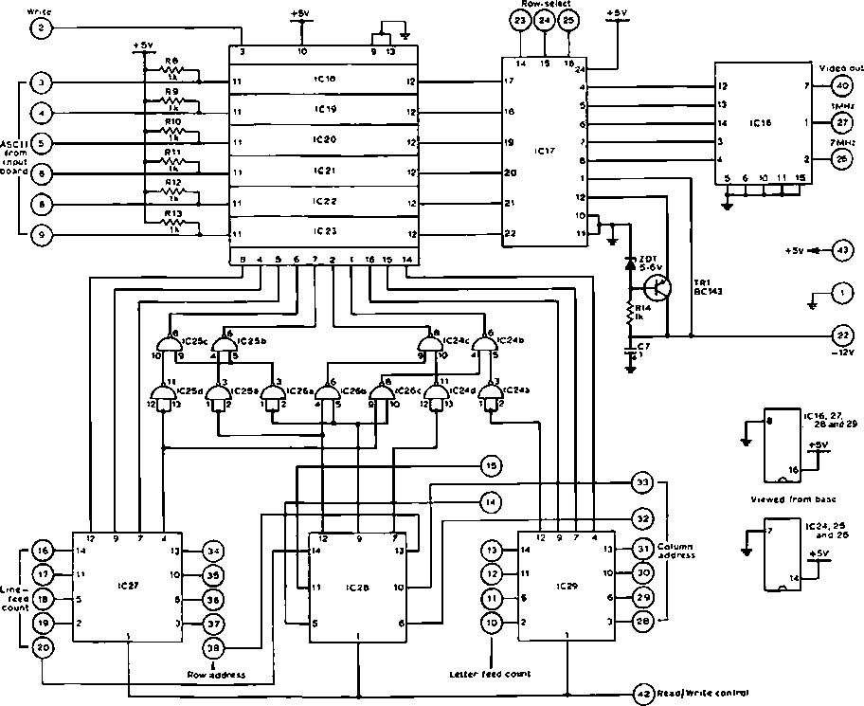
Fig 4. Memory and display board. Figures in circles are edge connector pin numbers. C8, 9,10 and 11 across -rSV supply are not shown. ICs 18-23 are connected in parallel on all pins except 11 and 12

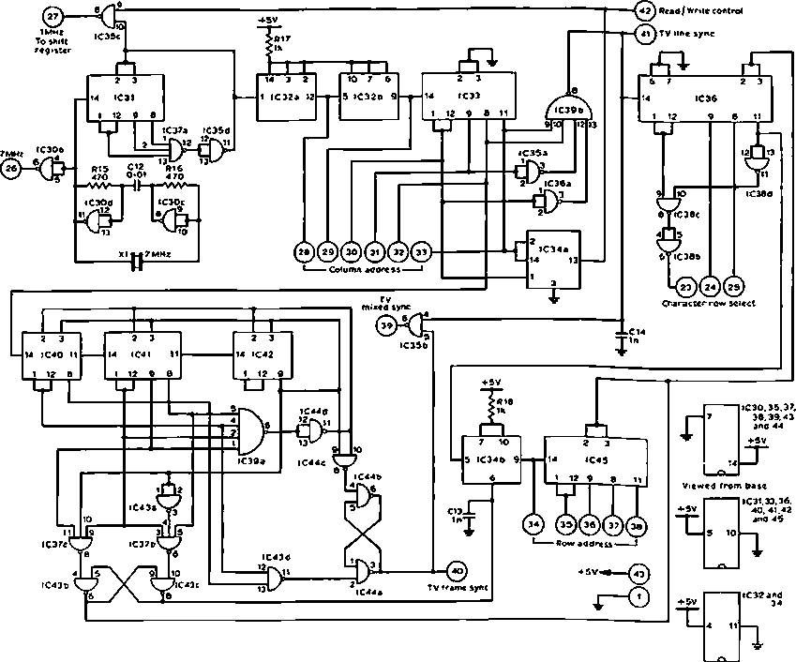
Flg 5. Timing board. Numbers in eireles are edge connector pln numbers. C15,16,17 and 18 across +5V supply are notshown

IC12b, the outputs of which denote the column and row in which the character is to be stored in the memory, The letter-feed counter is incremented each time a non-control character is received, and is reset to zero either when a carriage retům character is detected by IClOd, oř if the manual carriage retům button is pressed, oř if the end of a row is reached, in which čase the line-feed counter is also incremented via IClOa and IC9a. The line-feed counter is also incremented either when a line-feed character is detected by IC9c, or if the manual line-feed button is pressed. IC15a and b prevent contact bounce of this button from feeding more than one lineat a time. The line-feed counter is reset either if the page reset button is pressed oř if the counter tries to count past 23.
When the read/write control line goes low at the end of a displayed linescan it also switches over the memory address lineš, from the row and column address lineš on the timing board to the line-feed and letter-feed counter outputs just described. This is doně by 11 two-input multiplexers (two- way switches) controlled by the read/write control line like an 11-pole relay. In this way the incoming character is written into its correct location. Gate IC35c inhibits the
display during this time, so that this character is not displayed down the sides of the screen. When the read/write control line goes high again at the end of the flyback interval, IC4d goes low, taking uart pin 18 low. This intemally clears pin 19 to the low statě, clearing flip-flop IC12a, and the Circuit is then idle until the next rtty character has arrived in the uart.
To clear the screen the rde (receive data enable) pin on the uart, pin 4, is taken high from the clear button via IC6a, disabling the uart outputs which then float high to the “letters” character. Although this is a control character and is not normally written into the memory, the prom is pro- grammed to give the ASCII code for a blank space (000001). The clear button also holds the writb line low continuously, via IClOb, and this has the effect of writing blank spaces into all memory locations during the next display scan.
So far the memory has been described as a block of six-bit memory locations arranged in 24 rows of 40. The memory in fact consists of six devices, ICsl8-23, each capable of storing one bit in each location. The address lineš and the writb line are common to all six devices so that they all operáte together, with six inputs and outputs. The memory devices

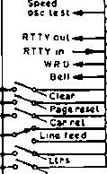
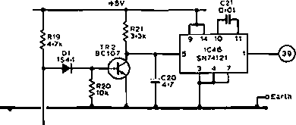
AMixed syne
UFrame syne
£LTl ^ 1 run« Ual *“"*■ U syne
Figs
Keyboard ^C19 »nput 0«1
W nu
ASCII codes t
Letler-
l«td
count
Line. fced
count
Read/Wnu
Input board
15
15.
- 7
12.
19
20
- 21 21 2£
25
- 27 26
29
- 21
32
33
34
35
36
- 36 39
4Q
41
42
43
Memory display
ooard
Video out tme syne
Tíming board
Fig 6. Interna! and external connections to the logic, viewed from the back of the edge-connectors
are in fact arranged in 32 rows of 32, not 24 rows of 40, but the conversion is doně quite simply by gates ICs 24-26, which in effect store characters for display in columns 32 to 40, in memory rows 24 to 32.

Keyboard
The keyboard Circuit shown in Fig 7 uses diodes to generate the required code patterns corresponding to each of the 31 keys. When a key is pressed the required code is set up on the five output lineš. Where there is a diodě from a key-line to an output-line that output is pulled low, and if there is no diodě that output line remains high—held by a “pull-up” resistor inside the uart to which the keyboard output lineš are connected. A sixth line is always taken low when a key is pressed, and this tums off TR2, allowing C20 to charge. If the key bounces, TR2 discharges C20, but about lOms after the last bounce the voltage of C20 will háve risen to trigger the monostable IC46, causing it to deliver, on pin 1, a short pulse low. This goes to the strobe input on the uart and starts it transmitting the rtty character; a start bit, followed by the five code bits in sequence. The uart has an input bufier, so if a second key is pressed while the first character is still being transmitted it will be stored in the bufier, and will be trans- mitted after the first with a two-bit gap between the two characters.
An alternativě to this home-built keyboard is a commer- cially available item. The author ušed a Clare-Pendar KB5 keyboard which, at the time of writing, is available on the second-hand market. The connections to the circuit are the same as the keyboard deseribed here, but the KB5 has a “two-key rollover” systém which makes typing at speed easier.

UHF modulátor
Fig 8 shows the circuit of a simple uhf modulátor for use with the vdu. A crystal oscillator feeds a harmonie generátor to deliver about 2mV at a frequency within the tv band. This is fed to an rf stage of the type designed for age control. With both logic inputs from the vdu high, RVI is ušed to set the collector current of this stage to the maximum gain condition. The logic input to RV2 is low between the syne pulses, and this raises the collector current to lower the rf
—i |  | )—i | )—< |  | < | H-< |  |  | )—( | •—i |  |  |  | 9—* | >—Í
 |  |  |  |  |  |  |  |  |  |  |  |  |  |  |  |  |  |  |  |  |  |  |  |  |  |  | —4
 |  |  |  |  |  |  |  |  | "H
 |  |  |  | M | r—* |  |  |  |  | —H | >— |  |  |  |  |  |  |  |  |  |  |  |  |  | f |  |  |  |  |  | t
 |  |  |  | —i | r— |  |  | —i | r— |  | —i
—i | )—i |  |  |  |  |  | —i | HH | )— | —<
Point* shown «
• consut of a diodc connected tnus
Murray
\<ede
inflUt
aoord
n a m x m {
Fig 7. Keyboard circuit. The pointe in clrdes connect to the uart on the input board shown in Fig 3

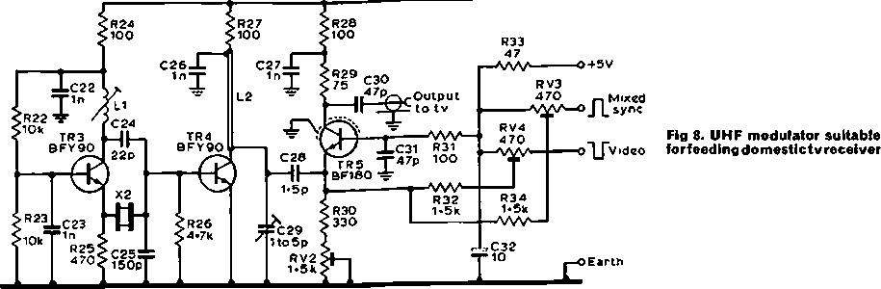
■0+12V
X

output. Thus RV2 is adjusted to set the black-level of the modulated output. The logic to RV3 is the display video, and when this goes Iow the collector current is increased still further, decreasing the rf output to the white level.
The author ušed a 67MHz fifth overtonc crystal from the junk box, with C29 tuned to peak up the cighth harmonie at 536MHz. The choice of crystal frequency and harmonie number will depend on available crystals and the frequencies of the iocal tv broadcast signals. The author built the unit in a tobacco tin, soldering earthed components directly to the box. A sereen should be installed between the input and output circuits of TR5. With RV2 and RV3 tumed to the +5V line, tuně the tv to a suitable harmonie and peak C29 and RVI for minimum background noise on the sereen, attenuating the signál to the tv if no noise is visible. Tura
RV2 up until the tv locks to the vdu syne, and then tum RV3 up until video is visible. These two presets can be adjusted more precisely by comparing the black and white levels of the display with those of a broadcast test-card.

Programming code converter memories
The programmable read-only memories 1C2 and IC3 in their natural statě háve all outputs Iow at all locations. The proceduře for programming them is as follows:
- Apply +5V to pin 16, set pin 15 to logic high, and set up the address code of the location to be programmed.
- To programme an output high, connect that output to -0-7 V and
- Raise pin 16 supply voltage to 10V and, within lOms,

Components list

Table 1. Code conversion prom programming chart
Munray code input plns  14 13 12 11 10 |  |  |  |  | Letters prom |  |  |  | Flgu |  |  | •  «  1  3
 |  |  |  |  | Output plna 123 456 70 |  |  | Character  dlsplayed | Output plna 123 456 70 |  |  | Charactor  dlsplayed
0 | 0 | 0 | 0 | 0 | 000 | 000 | 11 | (blank) | 000 | 000 | 11 | (blank)
0 | 0 | 0 | 0 | 1 | 101 | 000 | 01 | E | 110 | 011 | 01 | 3
0 | 0 | 0 |  | 0 | 010 | 000 | 11 | (Hneíeed) | 010 | 000 | 11 | (llnefeed)
0 | 0 | 0 |  | 1 | 100 | 000 | 01 | A | 101 | 101 | 01 | •hyphen
0 | 0 |  | 0 | 0 | 000 | 001 | 01 | epaco | 000 | 001 | 01 | space
0 | 0 |  | 0 | 1 | 110 | 010 | 01 | S | 111 | 001 | 01 | * apostrophe
0 | 0 |  |  | 0 | 100 | 100 | 01 | 1 | 000 | 1ti | 01 | 9
0 | 0 |  |  | 1 | 101 | 010 | 01 | U | 111 | 011 | 01 | 7
0 |  | 0 | 0 | 0 | 100 | 000 | 11 | (car ret) | 100 | 000 | 11 | (car ret)
0 |  | 0 | 0 | 1 | 001 | 000 | 01 | O | 000 | 100 | 11 | (whoareyou?)
0 |  | 0 |  | 0 | 010 | 010 | 01 | R | 001 | 011 | 01 | 4
0 |  | 0 |  | 1 | 010 | 100 | 01 | J | 001 | 000 | 11 | (betl)
0 |  |  | 0 | 0 | 011 | 100 | 01 | N | 001 | 101 | 01 | , comma
0 |  |  | 0 | 1 | 011 | 000 | 01 | F | 101 | 001 | 01 | %
0 |  |  |  | 0 | 110 | 000 | 01 | C | 010 | 111 | 01 | :colon
0 |  |  |  | 1 | 110 | 100 | 01 | K | 000 | 101 | 01 | (
1 | 0 | 0 | 0 | 0 | 001 | 010 | 01 | T | 101 | 011 | 01 | 5
1 | 0 | 0 | 0 | 1 | 010 | 110 | 01 | Z | 110 | 101 | 01 | •t-
1 | 0 | 0 |  | 0 | 001 | 100 | 01 | L | 100 | 101 | 01 | )
1 | 0 | 0 |  | 1 | 111 | 010 | 01 | W | 010 | 011 | 01 | 2
1 | 0 |  | 0 | 0 | 000 | 100 | 01 | H | 110 | 001 | 01 | #
1 | 0 |  | 0 | 1 | 100 | 110 | 01 | Y | 011 | 011 | 01 | 6
1 | 0 |  |  | 0 | 000 | 010 | 01 | P | 000 | 011 | 01 | Ožero
1 | 0 |  |  | 1 | 100 | 010 | 01 | O | 100 | 011 | 01 | i
1 |  | 0 | 0 | 0 | 111 | 100 | 01 | O | 100 | 111 | 01 | 9
1 |  | 0 | 0 | 1 | 010 | ooo | 01 | B | 111 | 111 | 01 | ?
1 |  | 0 |  | 0 | 111 | 000 | 01 | G | 000 | 000 | 01 | @
1 |  | 0 |  | 1 | 000 | 000 | 10 | ("98) | 000 | 000 | 11 | (flgs)
1 |  |  | 0 | 0 | 101 | 100 | 01 | M | 011 | 101 | 01 | .tulí stop
1 |  |  | 0 | 1 | 000 | 110 | 01 | X | 111 | 101 | 01 | / stroke
1 |  |  |  | 0 | 011 | 010 | 01 | V | 101 | 111 | 01
1 |  |  |  | 1 | 000 | 001 | 11 | (lira and cloar) | 000 | ooo | 10 | <Uw>
Notě: the symbol # Is programmed In "fi®s H** ae there Is no ASCII code for

Rl.2,3,4,5,6,7,8, 9,10,11,12,13,14, |  | Cl. 3,4. S, 6,7,8, 9, 10, 11, 15, 16,
17,18,36 | 1kíi | 17,18 | 1mF
R15,16, 2S, 35 | 470ti | C2,12,19, 21 | 001 uF
R19, 26 | 4-7kíi | C13, 14, 22, 23,
R20, 22, 23 | iOkn | 26, 27 | InF
R21 | 3-3kíi | C19 | 0-1 mF
R24, 27, 28, 31 | 100ti | C20 | 4-7pF
R29 | 750 | C24 | 22pF
R30 | 330ti | C25 | 150pF
R32.34 | 1-5kíi | C28 | 1-5pF
R33 | 47íi | C29 | 1-5pF
R37 | 390ti | C30, 31 | trimmer  47pF
RVI | 22kíi | C32 | 10mF
RV2 | 1-5kíi
RV3.4 | 4700 | IC1(General Inst) | AY5-1013
Dl, 2, 3, 4 | IS44 | IC2,3(Texas Inst) IC4, 5. 6, 10, 11, | SN74188AN
ZDI, 2 | 5-6V 1W | 15, 24, 25, 26, 30,
ZD3 | 4 IV 0-5W | 35,38, 43, 44 | SN7400
 |  | IC7 | NE555
XI | 7MHz | IC8,13,14,31,33,
X2 3rd or 5th overtone |  | 40, 41, 42, 45 | SN7493
LI (to suit frequency) 10t 20swg |  | IC12, 32, 34 IC16 | SN7473  SN741R5
5mm diameter for 70MHz L2 35mm straight 20swg wire |  | IC17 (Signetics) IC18, 19, 20, 21, 22, 23 (Signetics) | vil Itl Uw  2513/CM2140
3mm above ground plane |  | IC17 (Signetics) IC18, 19, 20, 21, 22, 23 (Signetics) | 2102-1B
TRI | BC143 | |C27, 28, 29 | SN74157
TR2 | BC107 | IC36 | SN7490
TR3, 4 | BFY90 | IC9, 37 | SN7410
TRS | BF180 | IC39 | SN7420
TR6 | BFY50 | IC46 | SN74121

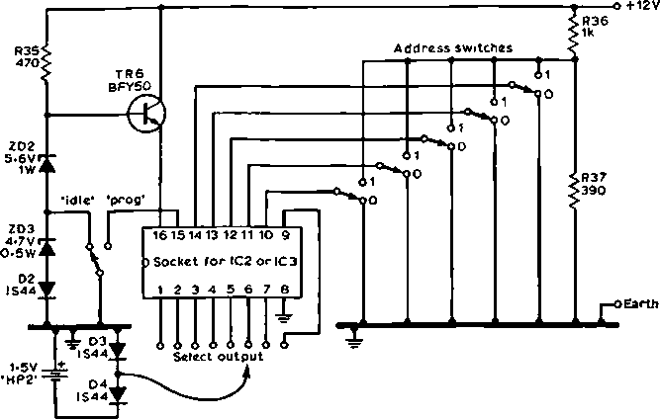
také pin 15 low for about 1$, thcn takc it high and, within lOms, lower the supply back to 5V.
Fig 9. Circuit for programmlng the PROMs. The supply should be capable of deliver- ing lOOmA
- Repeat 2 and 3 for cach output to be programmed high at this location, and repeat I, 2 and 3 for each location requiring prograniming.
Notě that outputs not programmed high will remain low and could, if required, be later programmed high, but once programmed high there is no way of bringing them down again, as programming these devices involves “blowing up” internal links. Fig 9 shows the Circuit of a jig for this purpose. Even if it is only to be used once it is worthwhile building the
jig on to a panel, with proper switches for the address lineš, sockets for the outputs and a wander plug for the — 0-7V supply. The programme button should be one with a snap action so that the change-ovcr is fast. A ncat and logical panel layout reduces the chance of an error in programming.
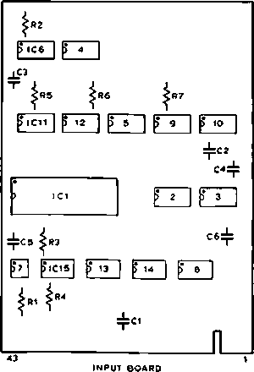
To check that an output has been successfully programmed, disconncct the — 0-7V supply and, with the supply pin at 5V, také the enable pin low. A voltmeter connccted between the output pin and the +5V line will read zero if that output has been “blown”, and +5V if not. If the proceduře deseribed appears too risky in view of the irreversible
P ¹C27 | p 28 | [> 29 ] j? 20
QIO^
_n
|> IC2S | | (i 23 | |  | P ’⁶ 1
 | ^R13 | ^R11 | ne| j_ l c5T
PlC26 | IP*⁴ I | p ²² 1 | P '• 1
R!2< R9<
I cuT
ser
 | P IC37 | | XI  (» »)  R15 ^{c}’* Rt6 -A/V- -||-
|> IC43 | |> | 42 | |J 4, | p | 40 | P 30 |
4=03  4=05 | ^RIB | C1&4²
[>'lC<A | (> | 39 | P 34 | P | 35 | p 31 |
4=cu | ""'i  <R17 | C18^;
plC45 | (> | 33 I P 32 I P | 36 | p 38 |
_n_
43 | TíMING BOARO | 1
KI4
IS 1 tri . .
p¹⁰⁶1 ¹⁷ 'O
memory/oisplay board
Fig 10. Layout of Věro dual-in-line boards, viewed from the copper side. le the components are on the opposlte side from that
shown

nátuře of programming errors, many suppliers of the proms háve facilities available for carrying out programming to order.

Construction hints
The author rccommcnds the use of dual-in-Iine layout boards, available from Věro Electronics or RS Components, for the three logic units. Fig 10 shows the layout of these three boards using this systém, viewed from the copper side. Self-fiuxing polyurethane-insulated wire is ušed for wiring between pads on the copper side of the board. This wire is available from Věro, but the writer ušed 32swg wire from a scrap transformer winding. This wire is similar to “enamelled” wire, but is a much lighter colour and the insulation melts witli a soldering iron.
Wire up all the supply and earth connections to each device first and check thoroughly for errors before proceed- ing. Errors involving the supplies usually result in destruct ion of an ic, but errors on input or output pins do not and, if not spotted before wiring is complete, can be found when the board is electrically tested. Build the timing board hrst and check, if a 'scope is available, that the line syne pulse is 4/ís wide with a 64/*s period, and that the frame syne pulse is 160/iS wide with a period of 20ms. Feed the combined syne to the display and check for correct synchronization. The video feed to the display can now be ušed as a fault-finding aid for the rest of the circuitry, displaying the logic signals present at any point in the Circuit. For example, the column address lineš will appear as vertical bars of different widths, and the row address lineš as horizontál bars. If the uhf modulátor is ušed for this, RV2 must be tumed up and RV3 down to prevent the signál being displayed from interfering with the synchronization of the tv.
Build the memory/display board next and, with that connected to the timing board and the write line held high, the display on switching on should appear as random characters, changing to a screenful of question marks if the write line is taken low. Again the display can be ušed to inspect any of the waveforms on this board. Finally the input board can be built and tested by linking the rtty input to the rtty output and typing in from the keyboard. On this board most of the signals change infrequently and, in the absence of a ’scope, are best checked with a testmeter or, in the čase of the very short pulses in the write-control area, by listening for clicks in a pair of headphones connected to the Circuit with a series capacitor.
Operation on the air is quite straightforward, if a little different from a conventional teleprinter. On switching on, press cle ar, páce reset and car ret so that copy starts at the top left hand comer of a clear sereen. If the copy turns to figures as a result of an error in the incoming signál, quickly press “Letters” to prevent further erroneous display. When the sereen is full, press clear, so that when copy starts at the top again it does so on to a clear sereen. If this is not doně, however, no copy will be lost, but the resulting display can be rather confusing. On transmission from the keyboard with local copy on the vdu, remember that the distant receiving station is most likely to be using a conventional teleprinter with a 70-character line. To savé wasting his páper it is possible to omit the carriage retům and line feed at the end of the 40-character vdu line, provided that these are sent before the next line on the vdu is three- quarters full. Rtty operation with a vdu is far less tiring than with a printer and, of course, is much quieter and does not use up any páper. At G3PLX the vdu is often left on, copying other station’s contacts while the operátor is busy with other things, even while in contact on another band on phone!
It is hoped that this article has shown that a home-built rtty display specifically for amateur purposes, although clearly a Iarge project, is no longer outside the capabilities of the kcen constructor. Apart from the uniťs uses for rtty, there is the new field of data transmission, recently announced by the Home Office, and the basic display design is compat- ible with existing data transmission systems such as Oracle, Ceefax and Viewdata.

Acknowledgement
This article would not háve been possible without the contri- bution of Hans Voltz, G8HVO, who helped to prove the design by building the first working unit. The author is most grateful to him. □

QTC
(Continued from p267)

500 editions of World Rádio Club
To mark its 500th edition, World Rádio Club invited an audience of shortwave enthusiasts to participate in the programme broadcast round the world by the BBC World Service on 16 and 18 February. Among those present was the President of RSGB, Lord Wallace of Coslany, who was interviewed by the programme’s presenter Frank Hennig. Questions from the audience were answered by a panel of experts: Bili Wood, head of the BBC’s Engineering Information Department; Desmond Colling of the International Short Wave League, and Henry Hatch, G2CBB, the pro- gramme’s resident engineering personality.
Ověř 32,000 members háve joined World Rádio Club since it began in July 1967. Designed espccially for shortwave enthusiasts and those who are fascinated by the technical aspects of rádio communication, it also catcrs for the
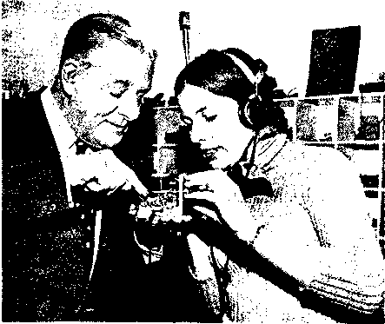
Henry Hatch demonstrates a crystal receiver he designed for listeners using such everyday household oddments as a cotton reel. (BBC photograph)

11 Marchwood Court, Broadsands Drive, Gosport, Hants.

